Group 2

IST 311

Pool Access System

10/14/18

# Login

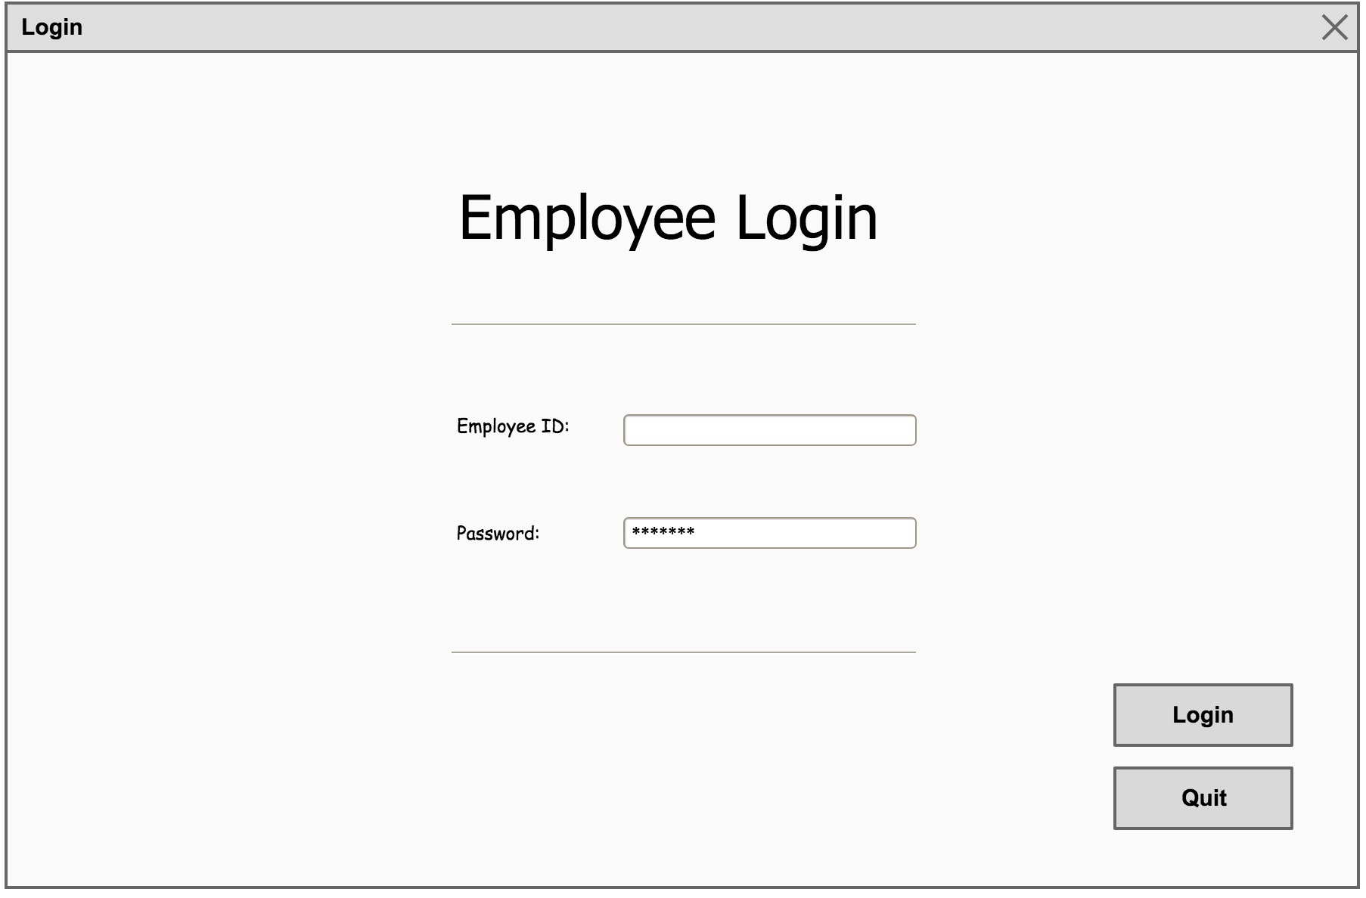

Employees will enter their employee ID (last name + first 2 letters of first name: ex. ortizda) and password. If authenticated, they will navigate to the main menu. If not, an appropriate error message appears and the fields clear so the user can try again.

Otherwise, the user can quit the application by clicking Quit.

# Main Menu

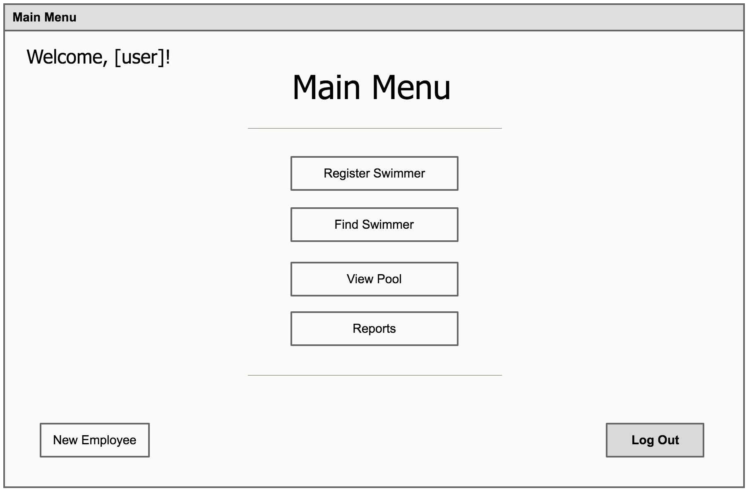

After authenticating, the user is presented with the main menu, which offers navigation to all the different use cases. Depending on the user role, some buttons may be disabled, such as Register Swimmer and New Employee. These are both operations that can only be performed by an Admins, so an Operator will not be able to navigate to those screens.

Otherwise, both user types can navigate to Find Swimmer, View Pool, Reports, as well as log out of the app.

# Find Swimmer

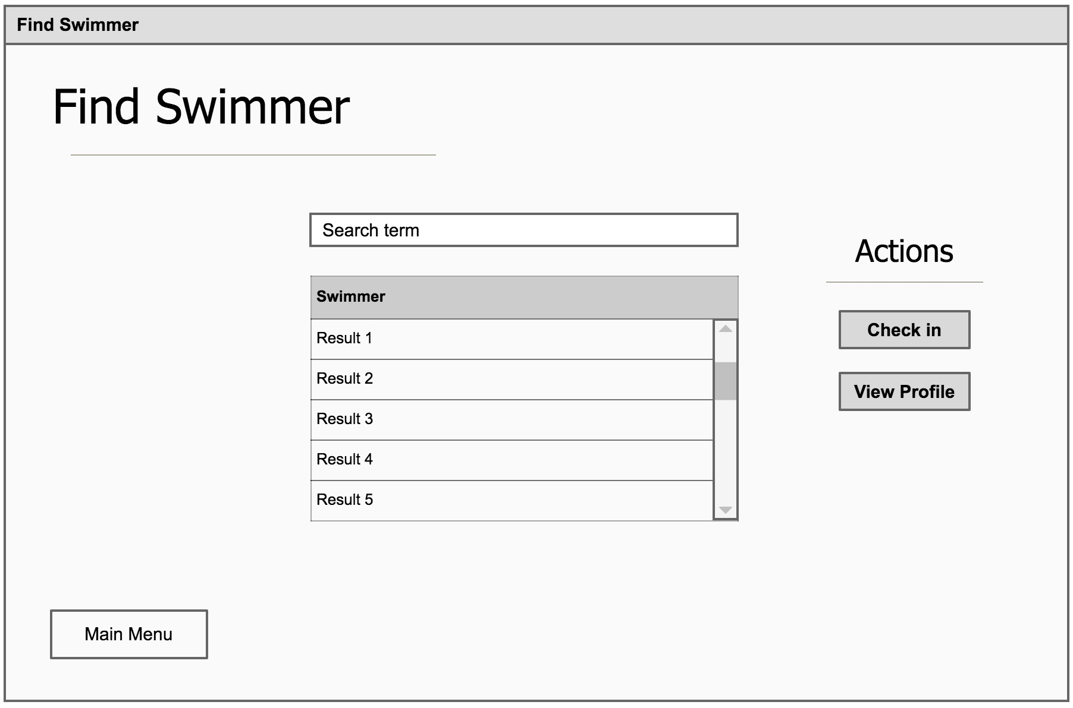

In the Find Swimmer use case, the user can search for swimmers using any keywords they would like. This is a live search, so it displays results as the user types as to minimize clicks. Keywords can include first or last name, phone number, or address.

The Action buttons are disabled by default, and only enabled when a result’s row is selected. The action selected pertains only to that specific swimmer. The check in button’s text will toggle between “Check in” and “Check out” appropriately which toggles the swimmer’s status.

The user can also choose to View Profile, which will take him/her to the swimmers detailed page which enables more functionality, depending on user’s role.

Alternatively, the user can return to the main menu.